REALISM
The style: Realism theatre became very popular in the 19th century and continued to be popular into the 20th century. The theatre style was created by Konstantin Stanislavsky who is a Russian actor and theatre director.
Realism is a style of theatre used to portray realistic emotions, actions and real life on stage. Realism theatre is used to show the stage as an environment rather than just a “stage.” The style emerged in the 19th century after several centuries of contributing factors, such as political and social ideas. The industrial revolution also played a big part as life for many became cramped and disease ridden. Stanislavski wanted to experiment with the idea of maintaining character. Stanislavski would dress himself up as a drunk and visiting the train station and later started to entertain people with a walk each morning dressed in character.
Stanislavski’s theatre style became very popular in the period after World War II predominately because people found it relatable.
Five interesting things:
- Stanislavsky was a co-founder of the Moscow art theatre
- It is believed that famous actors such as, Marilyn Monroe used realism in some of what is considered their best work.
- It was originally an experiment.
- Costumes were authentic
- Realism gained popularity quickly as the audience could relate to the characters
The acting: Actors would move and talk as normal people would in their everyday life. They would talk and move as everyday people and were very beleiveable. They would also portray very realistic emotions that were not over dramatized.
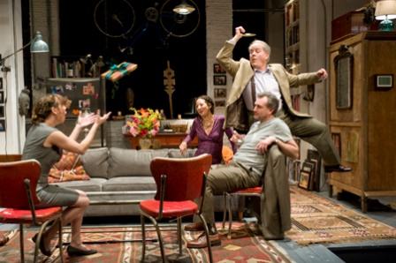
The stage: Stages were set up as realistically as possible to help reflect and portray the life like acting. Stages would be set up the same as an everyday house or environment. “box set” which is when there are three walls and an invisible forth wall.
Make up & lighting: Actors would have make up to make them look similar or the same as the character they were playing (for example people playing an older woman would have make up to make them look older). It was therefore very realistic.
Significant people:
Constantin Stanislavsky was a Russian actor, director and teacher. Stanislavsky was a significant person in the formation and use of realism theatre as he was the individual who made the idea of acting in a real way. He developed various acting techniques which are known as ‘The Stanislavsky Method’ which are still studied by actors today. One of the predominant goals of this method is to portray believable, natural people in performance.
Henrik Ibsen was another significant individual who was considered the papa of modern realism. He was Norwegian and a playwright, director and the next famous person in line after Shakespeare. He is considered the papa of modern realism because he wrote some of the first plays that didn’t include superheros of women in trouble.
Some other playwrights are. Anton Chekhov. Lee Strasberg, August Strindberg, George Bernard Shaw, David Belasco
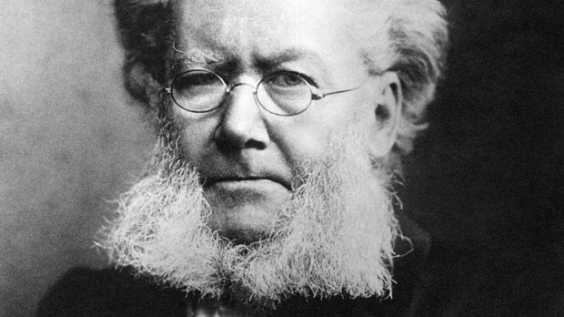
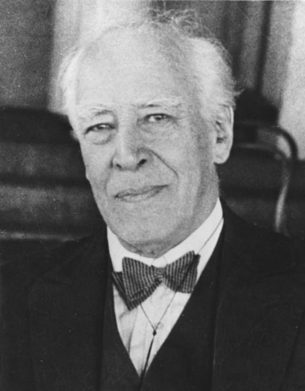

Henrik Ibsen
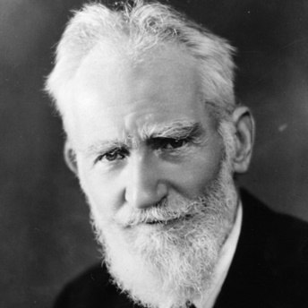

Konstantin Stanislavsky

George Bernard Shaw

Scripts and performances:
- Many of Ibsen’s plays were based on the idea of theatrical realism. Some of his most well known are A Doll's House (1879) and Ghosts (1881)
- David Belasco wrote ‘’Girl Of The Golden West.
- George Bernard Shaw also wrote a total of 63 different plays.

Bibliography.
Cash, J. (2010) ‘Realism Theatre’, accessed 19 August 2016. Available at
http://realismtheatre.blogspot.com.au/
Edgeton, B. (2014) ‘Bite size: Naturalism and Stanislavski’, accessed 15 August 2016. Available at http://www.bbc.co.uk/education/guides/zxn4mp3/revision/3
Jones, J n.d. (2012) The Modern Theatre: Realism, accessed 15 August 2016. Available at http://homepage.smc.edu/jones_janie/TA%202/8Realism.htm
Konstantin Stanislavski 2016, accessed 15 August 2016. Available at https://en.wikipedia.org/wiki/Konstantin_Stanislavsky .
Turner, B. (2016) ‘Henrik Ibsen’, accessed 23 August 2016. Available at https://en.wikipedia.org/wiki/Henrik_Ibsen .

