The Style
- Find the approximate date the style emerged (began).
The Elizabethan theatre began in 1576.
- Note in your own words, the style of theatre and how or why it emerged. (100 wds).
Queen Mary the first died and Elizabeth succeeded her to the throne. Elizabeth wanted more new types of plays. The Elizabethan era was known for a few things like a flowering of the arts which has never been seen in England, and created playhouses and playwrights including William Shakespeare. Elizabeth never felt safe, plots against her were always brewing. A lot of people considered her claim to the throne to be illegitimate and her cousin Mary, Queen of Scots to have the rightful claim.
- Research and note five interesting or unusual facts about this style.
- Poor people were called the groundlings
- A play was a lively event
- People expected to see a new play everyday

The Conventions Find out and note
(Performance Conventions)
- how actors used their expressive skills when performing in this style
It was very dramatic and poetic. The lower class character would speak prose, while upper class characters spoke more stylised and more in rhythmic speech patterns. It was sometimes unrhymed.
(Theatrical Conventions)
- what sort of stages the style used
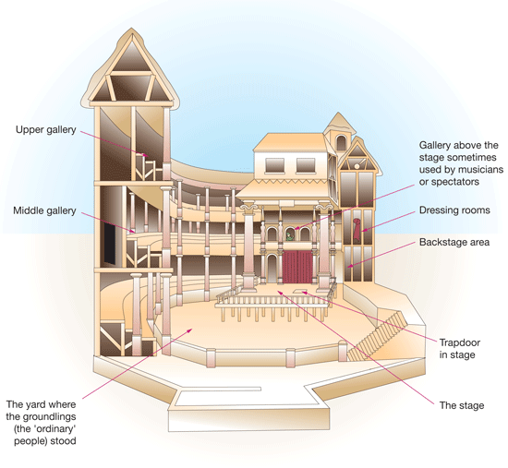
- how the style used set, props, costume, make-up, sound, lighting and
Their clothes we symbolic, for example if they were wearing black clothes it was seen as evil and dark, if you wore white showed love. They didn’t use props, they performed with nothing else on the stage and sometimes they used sound effects. Because in Shakespeare plays men were the only gender who acted, women did not, men then had to dress up as women.
multimedia/special effects.
Very little were used.
Significant people
- Create a list of people who are connected to or influenced the style.
- William Shakespeare
(They might be a playwright (i.e. Ionesco, Shakespeare), director (i.e. Brecht,
Stanislavski) or person from history (Plato, Queen Elizabeth I, Adolf Hitler)
- Select two people from your list and explain their influence and give a brief

biography of each person. (100 wds)
William Shakespeare- Shakespeare made the acting industry from past to present. His plays were very different compared to the plays done by the author before hand. Many, many people came from all of the world just to watch his plays which shows how good he was at what he did. The emotion in his plays touched audiences hearts.
Christopher Marlowe- Christopher Marlowe stopped acting in plays at the Elizabethan Theatre before he even died. He inspired Shakespeare to come to the Elizabethan Theatre. Which is a pretty big thing considering how successful he has come. He is known for using the blank verse and their overreaching protagonists.
• Scripts/performances
- Research the playwrights/practitioners from your style and create a list of at least 5 plays/productions in your style.
1590 Spenser's Faerie Queen (1-3)
1590 Marlowe's The Jew of Malta
1591 Sidney's Astrophil and Stella
1592 Kyd's The Spanish Tragedy
1592 William Shakespeare's Henry VI Part I
1592 William Shakespeare's Henry VI, Part II

